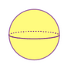
Geometrical Forms

1-dimension

Noun Adjective
line linear/straight

2-dimensions

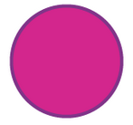
Nouns Adjectives
bend/curve bent/curved
circle circular/round/rounded
semicircle semicircular
ovum/egg oval
ellipse elliptical
rhombus rhomboid
(an irregular rhombus is sometimes called a “kite”)
trapezium trapezoid
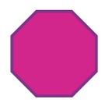
triangle triangular
square square
rectangle rectangular
pentagon pentagonal
hexagon hexagonal
octagon octagonal
decagon decagonal
polygon polygonal
parallelogram ------

3-dimensions

Nouns Adjectives
sphere spheric/spherical
cube cubic/cuboid
cone conical
cylinder cylindrical
pyramid pyramidal

Source: https://byjus.com/maths/geometric-shapes/

